EXCEL MODULE END ASSIGNMENT

E‑Commerce Project Report

1. Introduction
This report presents an analysis of an E‑Commerce dataset developed as part of an Excel capstone project. The project integrates customer, product, store, and sales data to provide insights into business performance, customer behavior, and sales trends. Microsoft Excel was used for data preparation, analysis, pivot tables, and dashboard creation.

2. Objectives of the Project
The main objectives of this Excel project are: - To consolidate multiple data sources into a single, clean dataset - To analyze sales performance across products, stores, and regions - To understand customer demographics and loyalty levels - To build pivot tables and an interactive dashboard for decision‑making

3. Dataset Description
The project consists of multiple worksheets: -
Customer_Dim: Contains customer demographics such as age, gender, city, state, and loyalty level
Product_Dim: Includes product details like category, sub‑category, brand, cost, and stock
Store_Dim: Holds store information including store name, region, and store type
Sales_Fact: Captures transactional sales data

4. Data Preparation And Cleaning Steps:
1.Import Dataset into excel for Analyse
2.Checking Duplicate values in Unique value columns
Here the cleaning Steps of various given Sheets.
Customer_Dim:
- Find some Inconsistent data in Customer ID Column and replace with Appropriate Values.
(C-1464 – CUST1464)
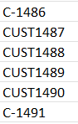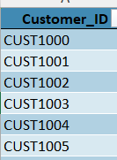
- Using Proper and Trim Functions in Name Column.
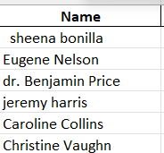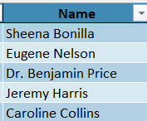
- Using Find and Replace to change inconsistent data in country Column (United States America – “USA”)
- Missing values found in Loyalty Level Column and Replace with “Platinum” Using Most Repeated Values(MODE).
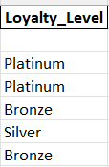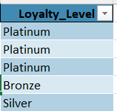

Product_Dim:
- Inconsistent Data Found in Product Column , Replaced with appropriate Value.
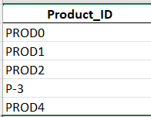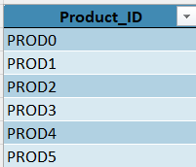
- Missing Values Found in Cost column and Replaced with an averages values following group by Category And Sub-Category Data.
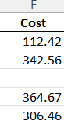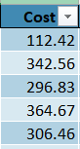

Merged Data:-
Using Vlookup And Xlookup to combine all worksheets in one single Combined Datasheet, Named as “E-Commerce Combined Data”.
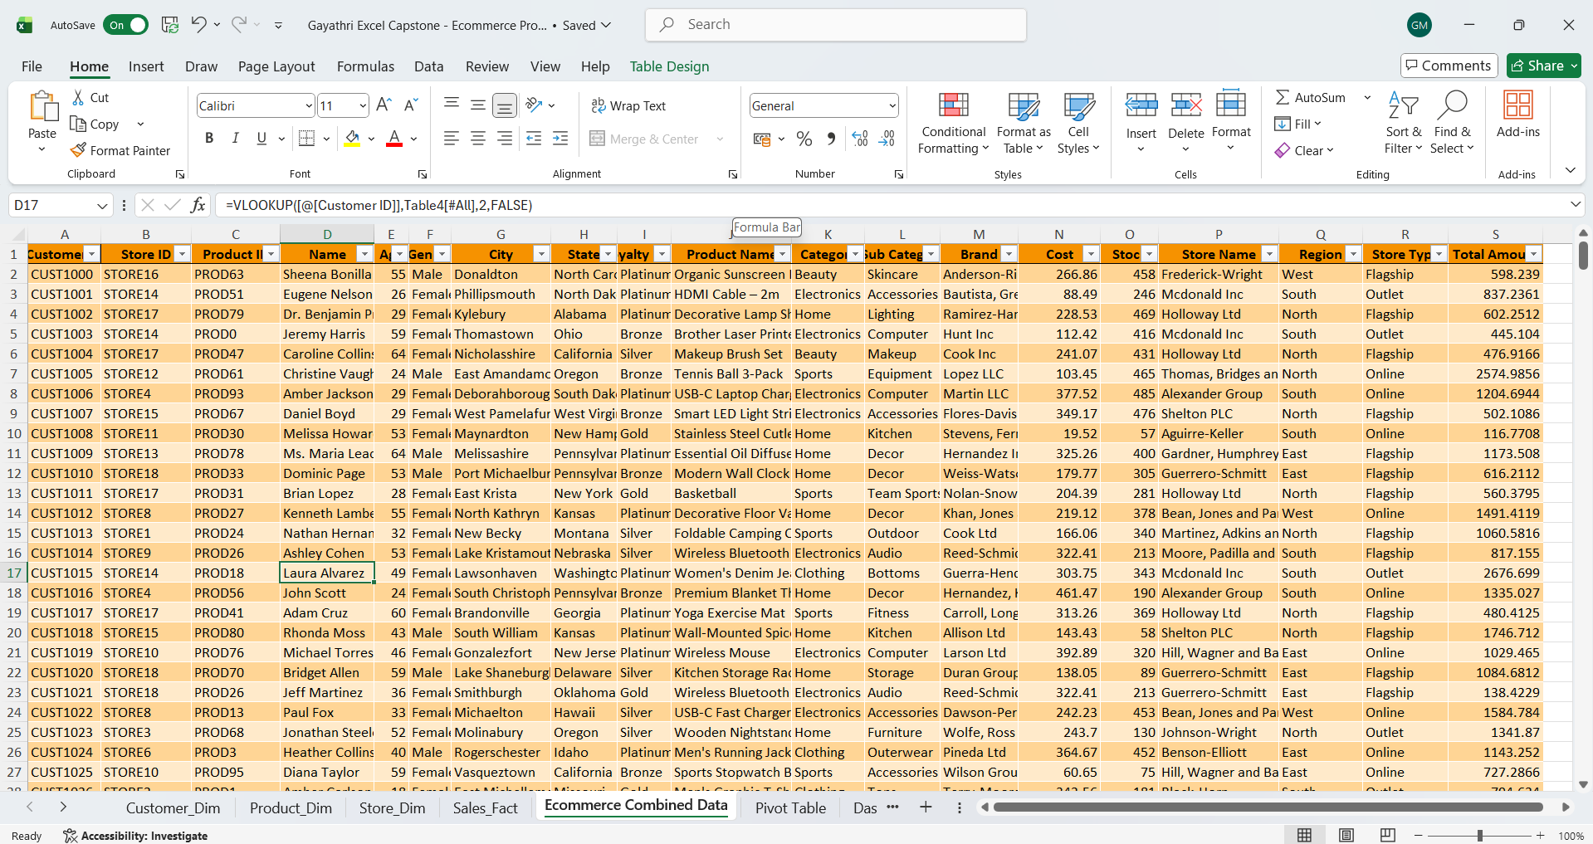

5. Data Analysis and Insights
Using Excel pivot tables and charts, the following analyses were conducted:
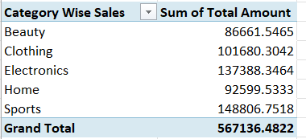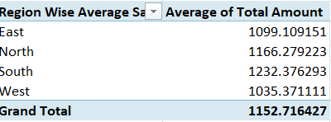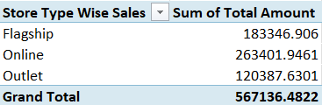

5.1 Sales Performance
- Sales were analyzed by product category and sub‑category to identify top‑performing items
- Regional analysis highlighted differences in sales across North, South, East, and West regions
- Flagship stores generally generated higher sales compared to outlet stores

5.2 Customer Analysis
- Customers were segmented by loyalty level (Bronze, Silver, Gold, Platinum)
- Higher loyalty tiers contributed a larger share of total revenue
- Age and gender distributions helped identify key customer demographics

5.3 Product and Inventory Insights
- Stock levels were reviewed alongside sales to identify fast‑moving and slow‑moving products
- Electronics and Beauty categories showed strong overall performance
- Brand‑level analysis revealed which brands contributed most to revenue
CHARTS:
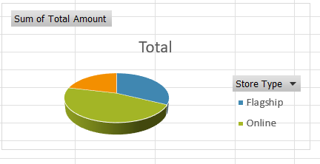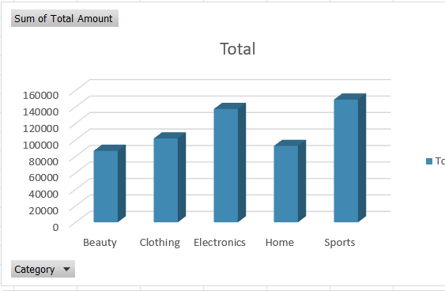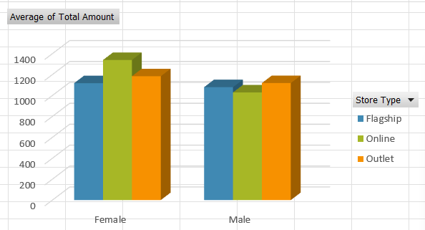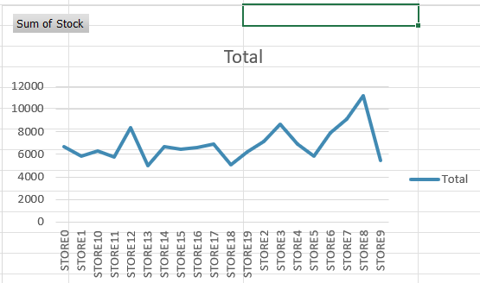

6. Dashboard Overview
An interactive Excel dashboard was created to visualize key metrics, including: - Total sales and average sales - Sales by category, region, and store type - Customer loyalty distribution - Top products and brands
Slicers and filters were used to allow dynamic exploration of the data.

Here the screenshot of Dashboard:
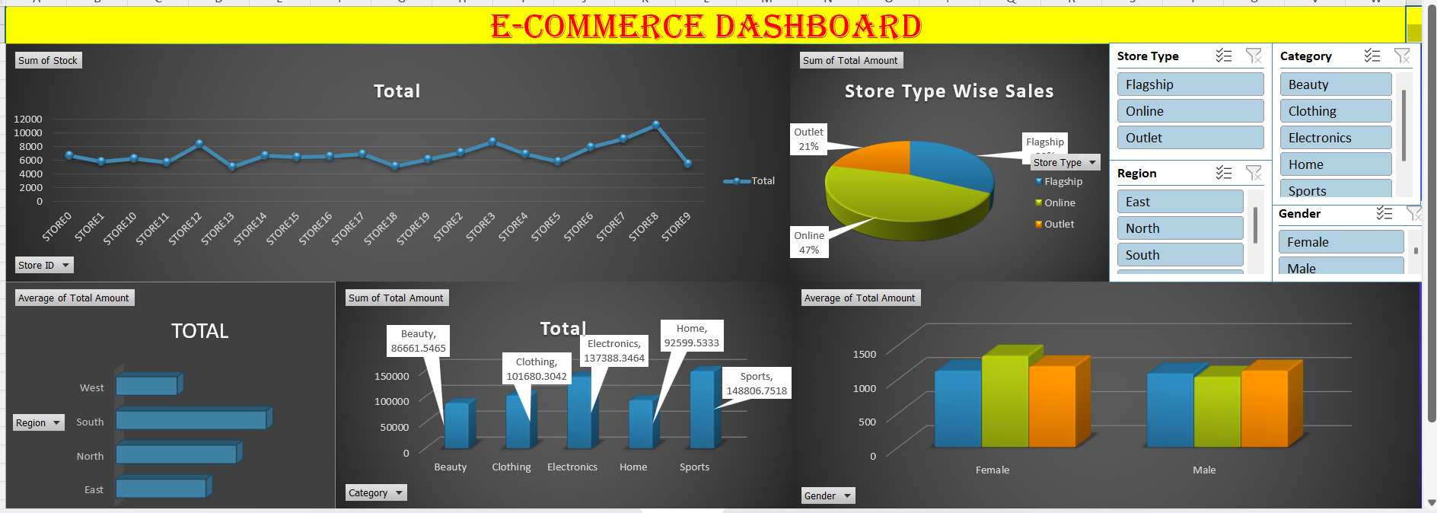

7. Key Findings
- Customer loyalty has a strong impact on revenue generation
- Certain regions and store types outperform others consistently
- A small group of products and brands accounts for a significant portion of total sales
- Dashboard visualizations improve clarity and support faster decision‑making

8. Conclusion
This Excel E‑Commerce project demonstrates how raw data can be transformed into meaningful business insights using Excel tools such as pivot tables, charts, and dashboards. The analysis supports data‑driven decision‑making in areas such as marketing, inventory management, and sales strategy.

9. Recommendations
- Focus marketing efforts on high‑value loyalty customers
- Optimize inventory for high‑demand products
- Expand strategies used by top‑performing regions and stores
- Regularly update dashboards to track performance over time

Attachments:
Excel File: Gayathri Excel Module End Assignment Excel File
Dashboard Screenshot:Dashboard Screenshot pdf file

